P.Gayathri
192424324
ECA1001

a)8-BIT ADDITION WITH CARRY USING DIRECT
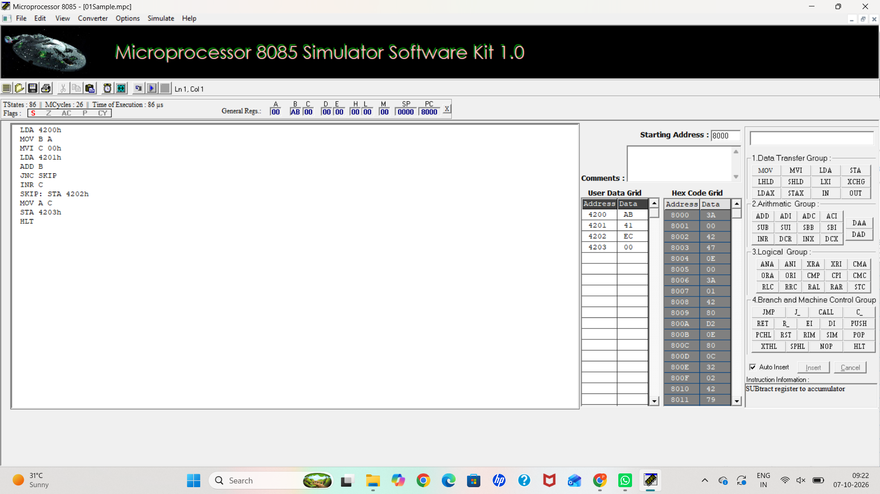
b) 8-BIT ADDITION USING INDIRECT ADDRESSING
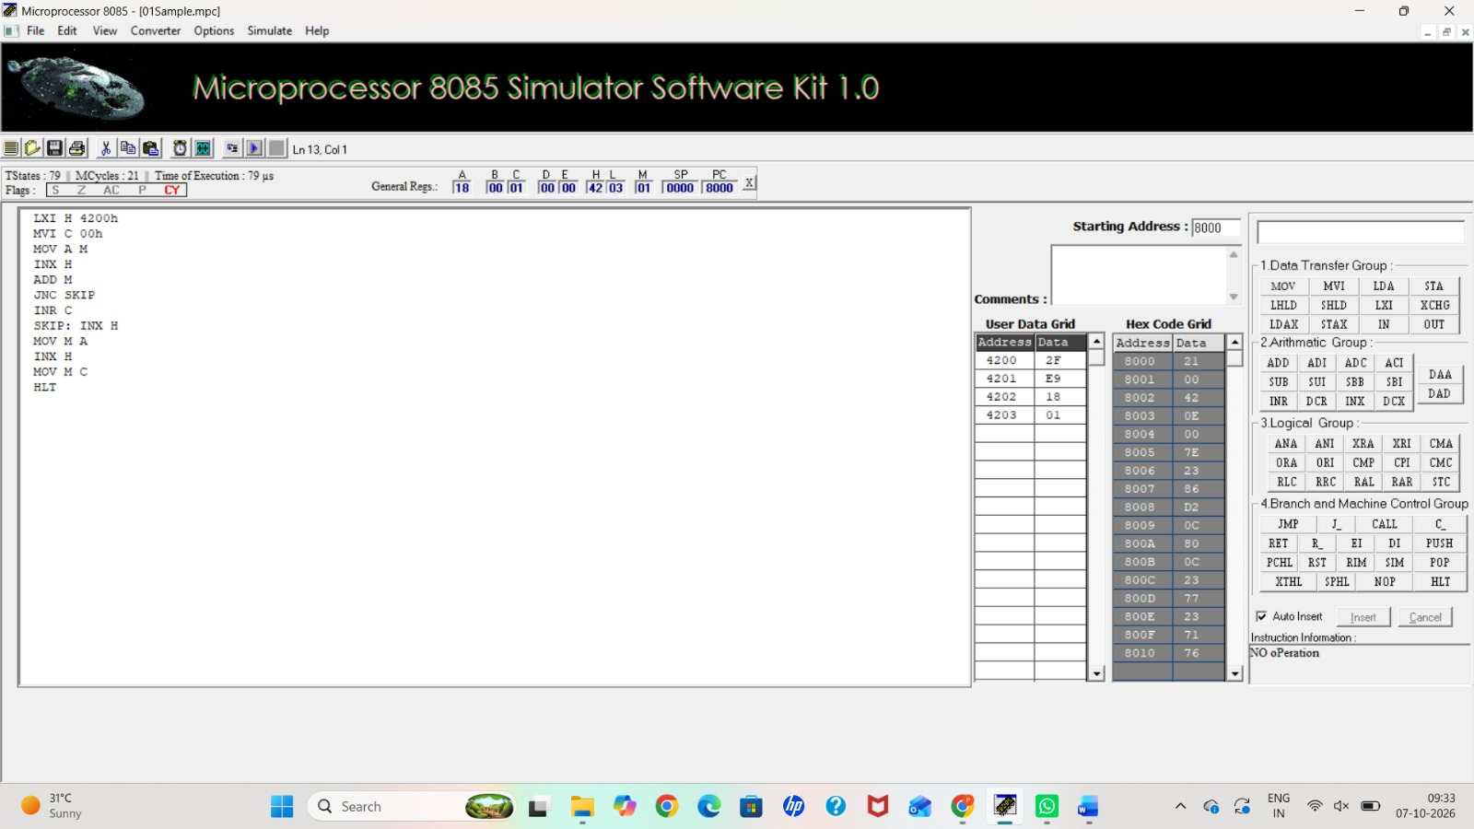

c) 8-BIT SUBTRACTION WITHOUT BORROW
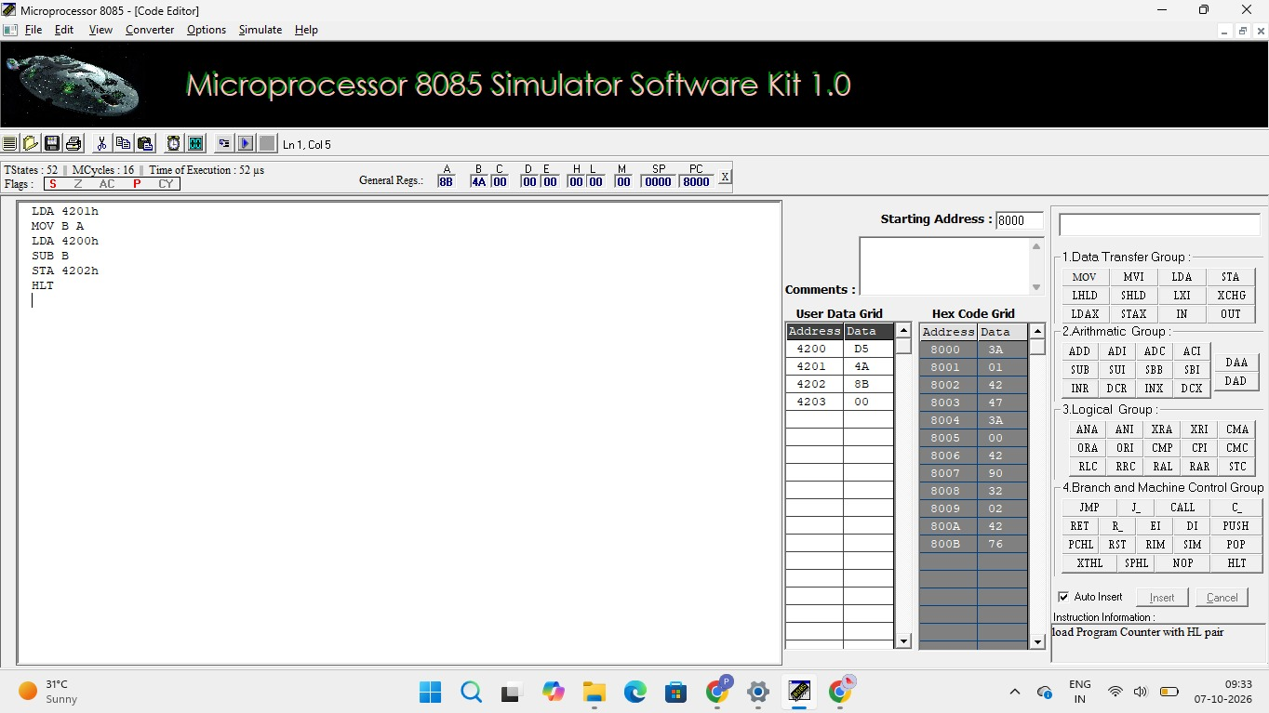

d) 8-BIT SUBTRACTION WITH BORROW USING DIRECT ADDRESSING
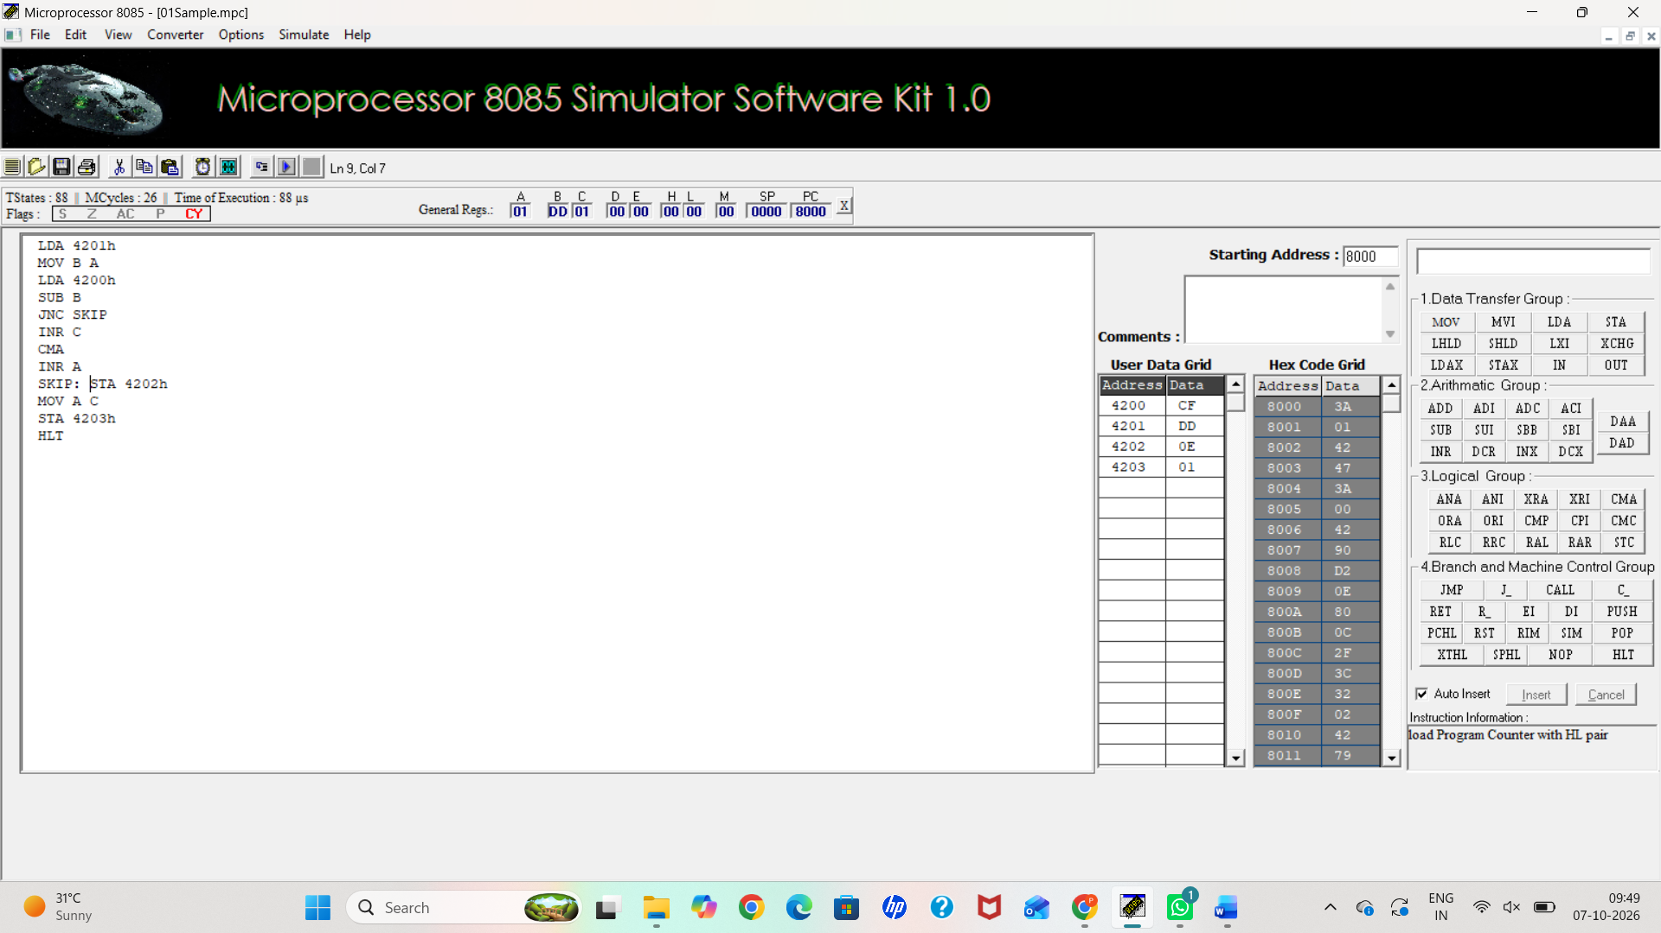

e) 8-BIT MULTIPLICATION OPERATIONS USING 8085 MICROPROCESSOR
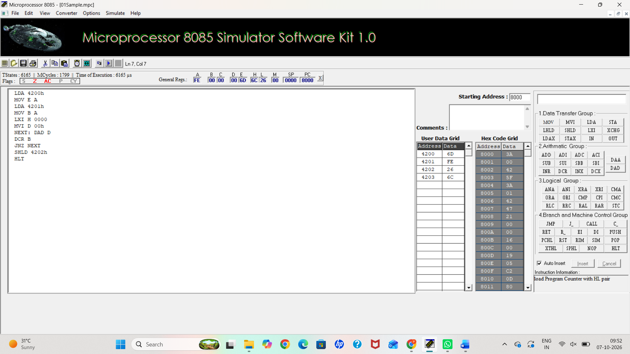
f)
8-BIT DIVISION OPERATIONS USING 8085 MICROPROCESSOR
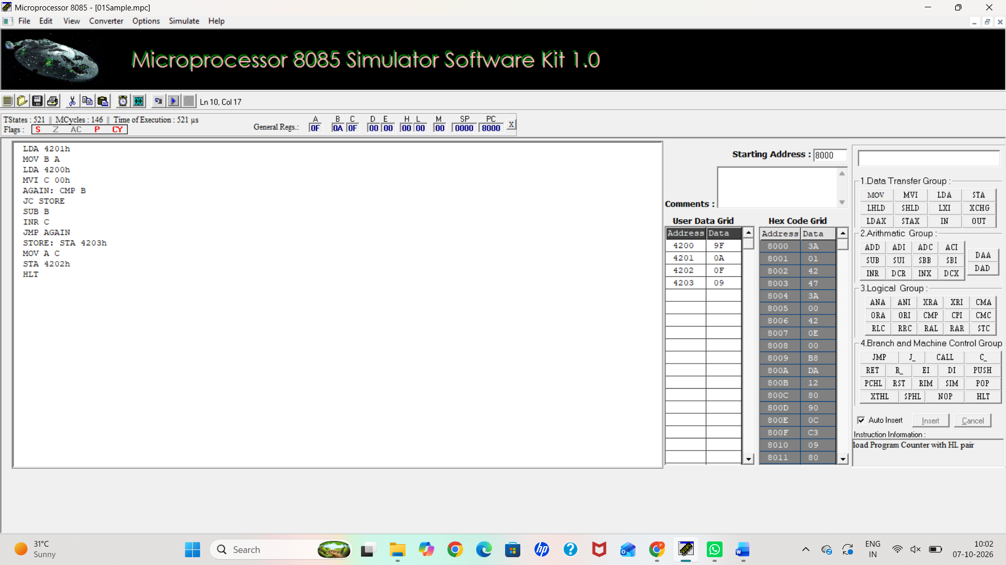

2)a: SORT AN ARRAY OF DATA IN ASCENDING ORDER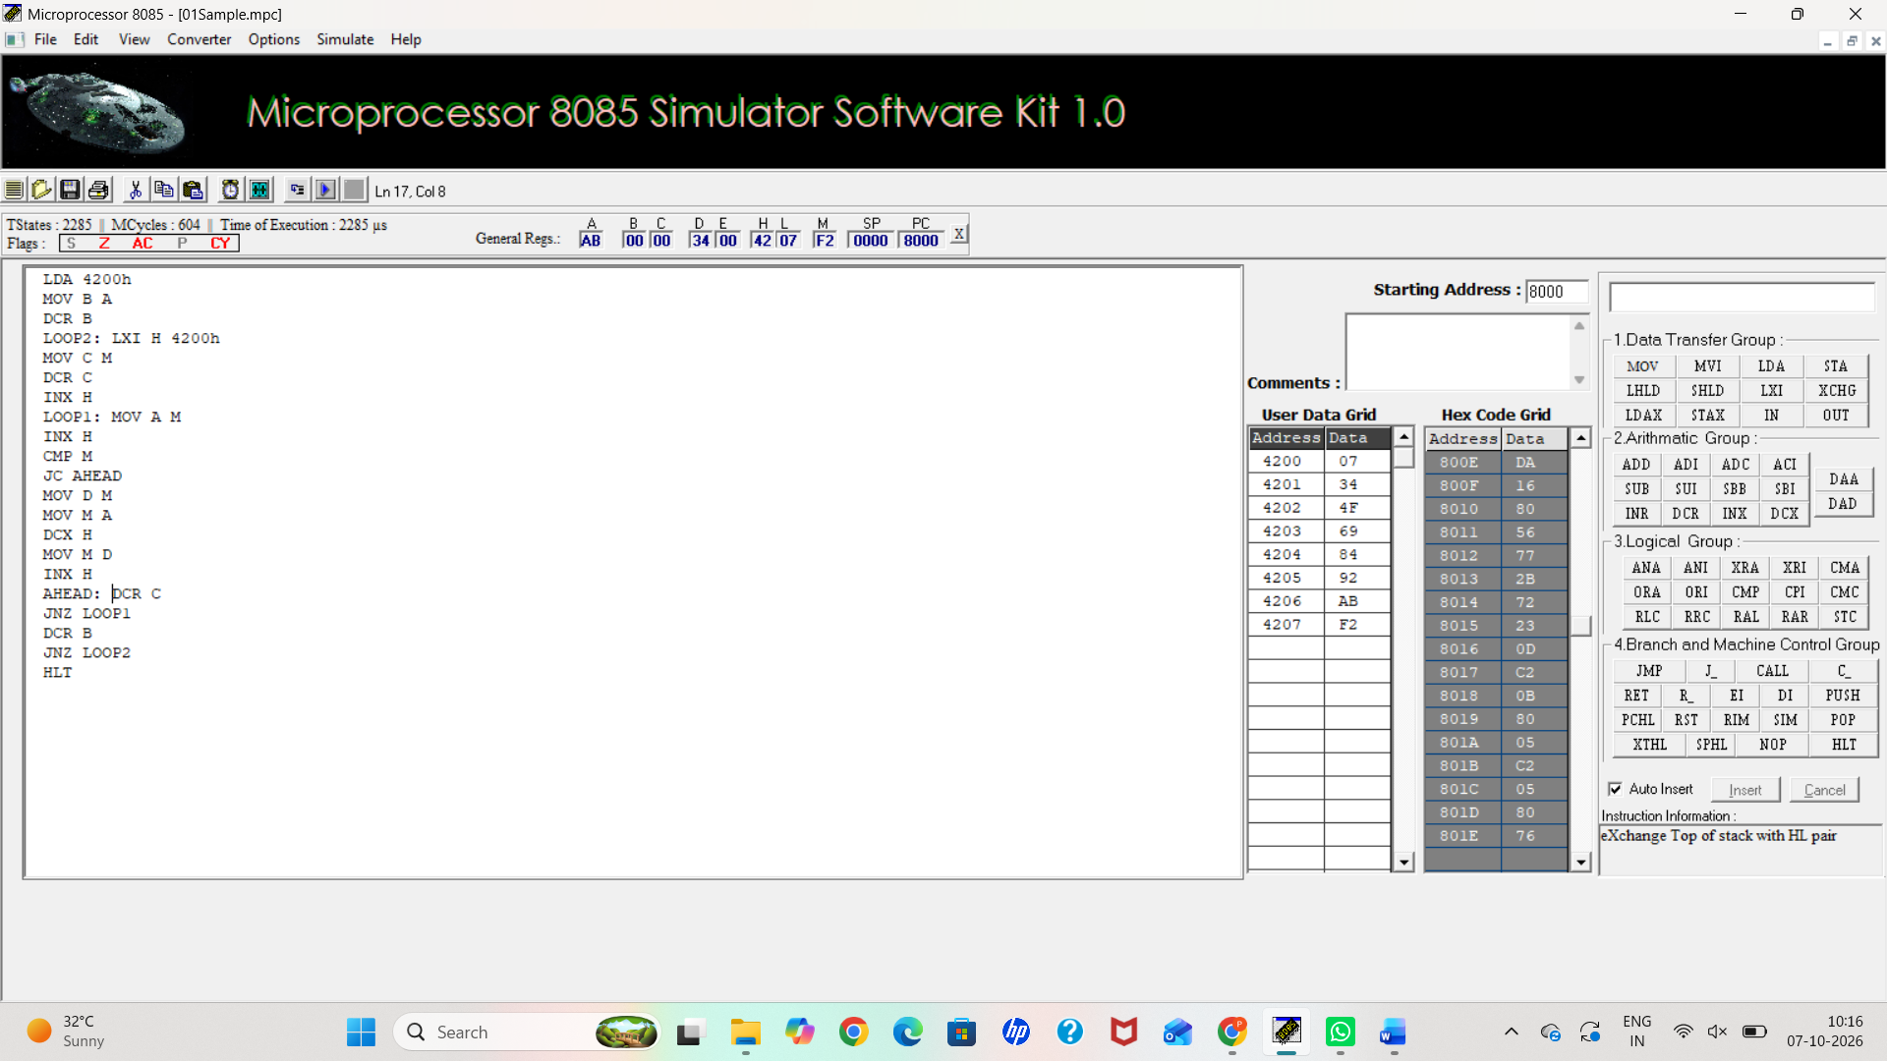
2b)
SORT AN ARRAY OF DATA IN DESCENDING ORDER
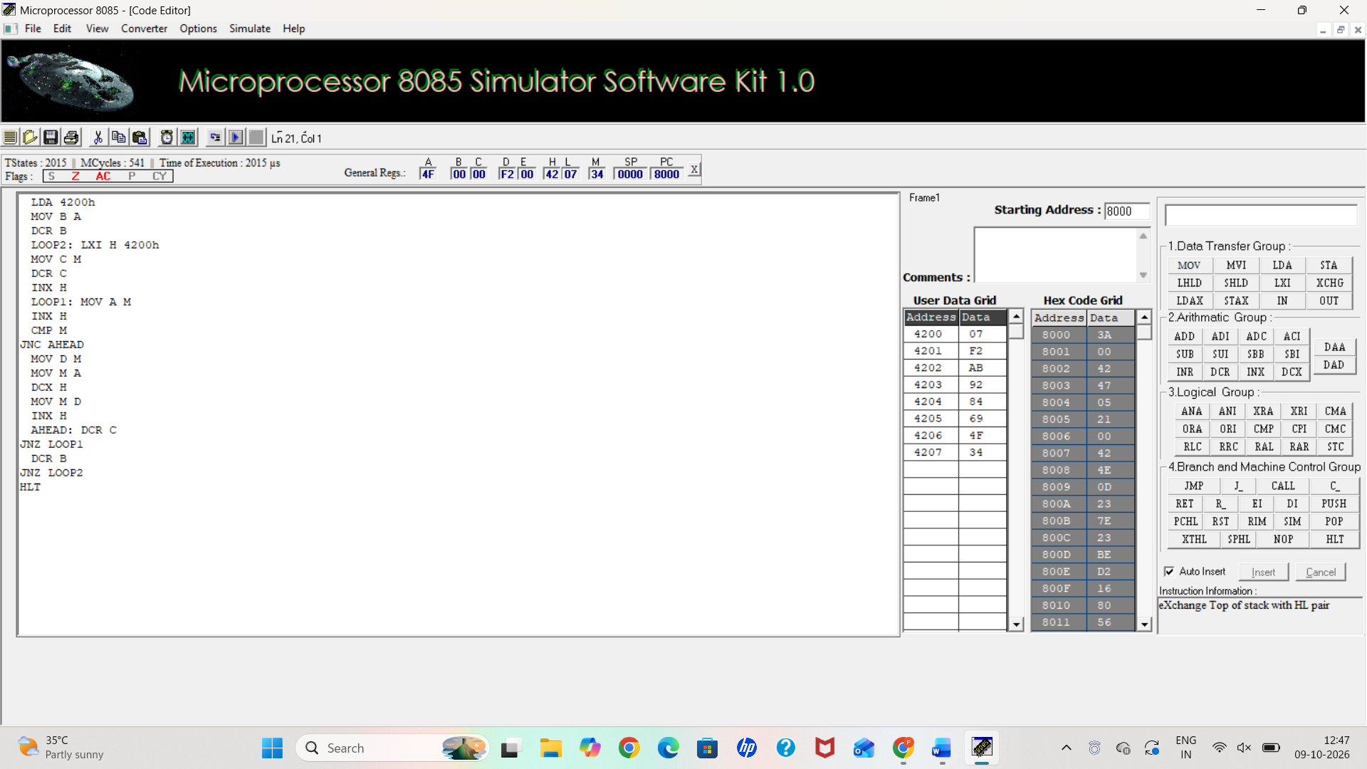

3) ASCII CODE TO HEX CODE CONVERSION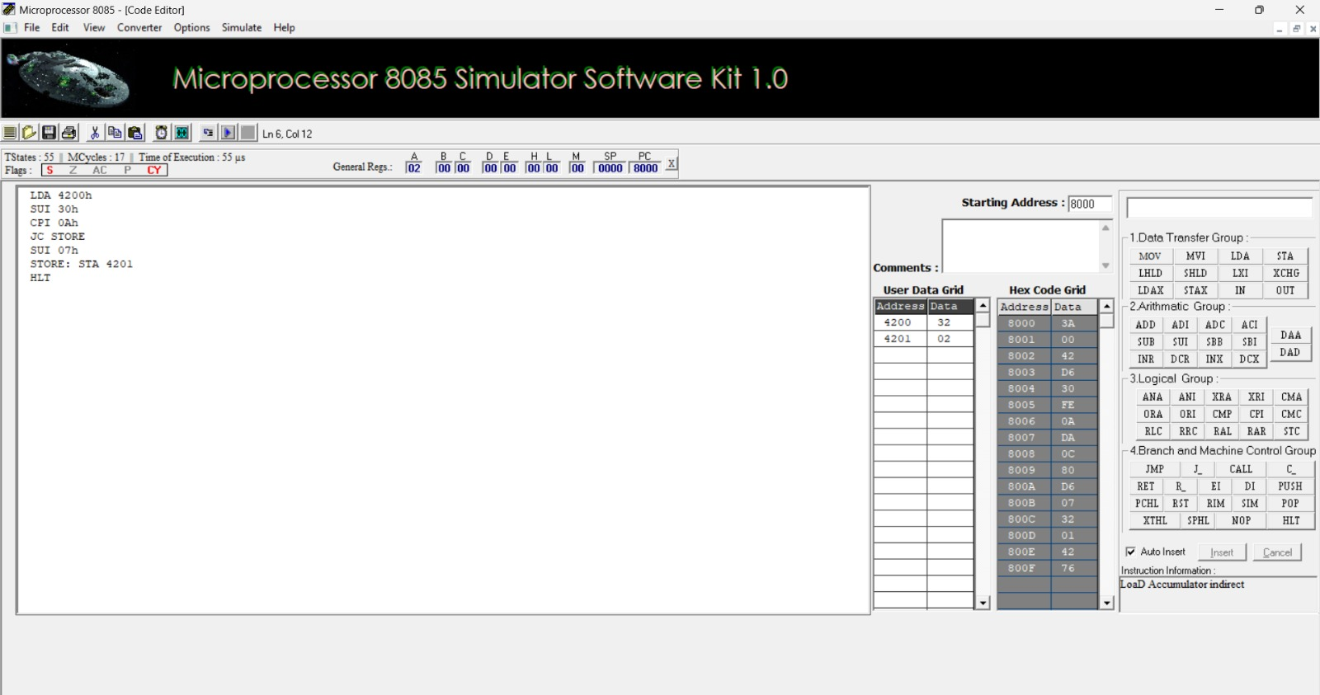
4) TRANSFERRING A BLOCK OF DATA BETWEEN MEMORY LOCATIONS
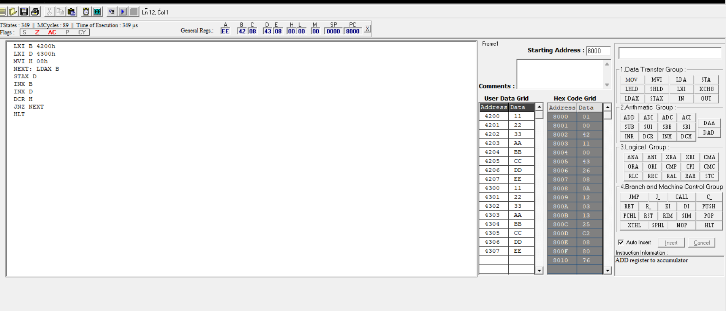

5a. MASKING AND SETTING OF LOWER NIBBLES ON GIVEN DATA
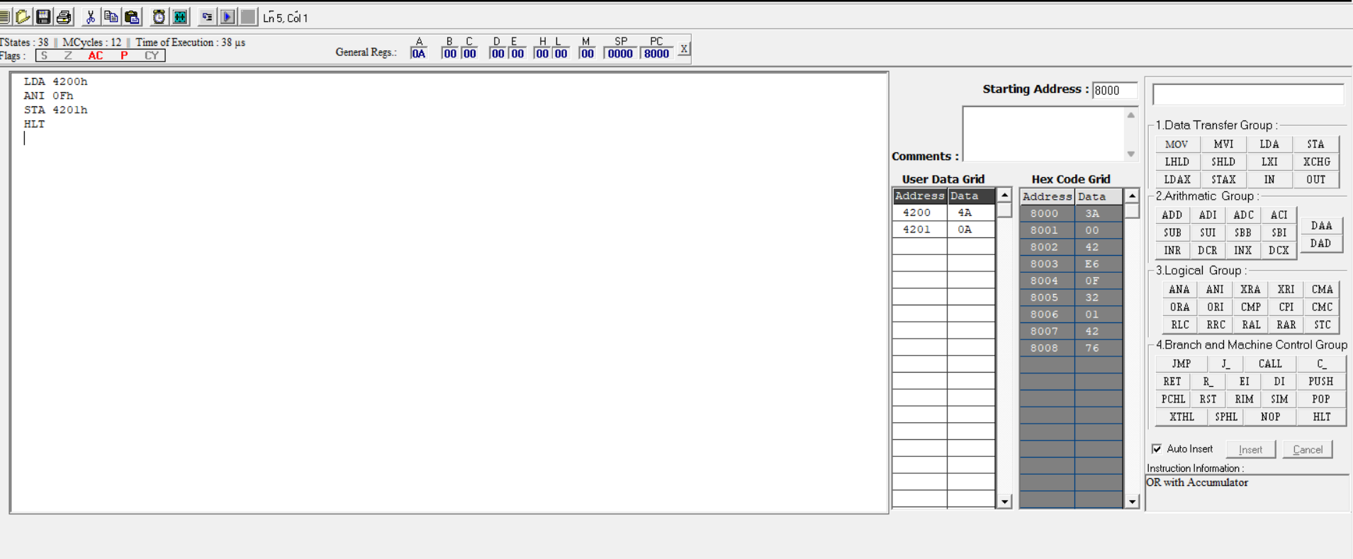
5b.ONE’S AND TWO’S COMPLEMENT
